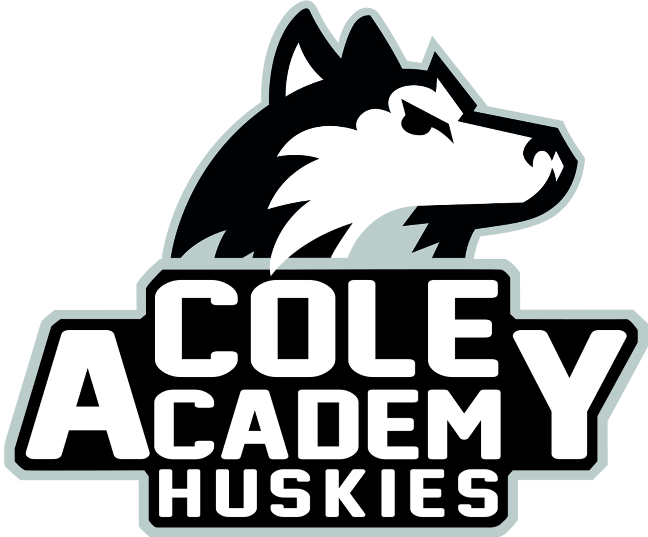
Cole Academy Cole Academy East
1915 W. Mount Hope 2921 E. Coleman Road
Lansing, Michigan 48910 East Lansing, Michigan 48823
517.372.0038 517.580.3470
Fax 517.372.1446 Fax 517.372.1446

School Annual Education Report (AER) Cover Letter

January 30, 2024
Dear Parents and Community Members:
We are pleased to present you with the Annual Education Report (AER), which provides key information on the 2023-24 educational progress for Cole Academy. The AER addresses the complex reporting information required by federal and state laws. The school’s report contains information about student assessment, accountability, and teacher quality. If you have any questions about the AER, please contact Dr. Thomas for assistance.
The AER is available for you to review electronically by visiting the following website https://bit.ly/37qhH5I, or you may review a copy in the main office at your child’s school.
For the 2023-24 school year, schools were identified based on previous years’ performance using definitions and labels as required in the Every Student Succeeds Act (ESSA). A Targeted Support and Improvement (TSI) school is one that had at least one underperforming student subgroup in 2018-19. An Additional Targeted Support (ATS) school is one that had a student subgroup performing at the same level as the lowest 5% of all schools in the state in 2017-18. A Comprehensive Support and Improvement (CSI) school is one whose performance was in the lowest 5% of all schools in the state or had a graduation rate at or below 67% in 2016-17. Some schools are not identified with any of these labels. In these cases, no label is given.
Our school has not been given one of these labels.
Key challenges for Cole Academy East mirror pandemics challenges across the nation. Emerging evidence shows that the pandemic has negatively affected academic growth, widening pre-existing disparities. In core subjects like math and reading, there are worrisome signs that in some grades students might be falling even further behind pre-pandemic expectations. Nearly all students have experienced some challenges to their mental health and well-being during the pandemic and post pandemic season. We employ a full-time interventionist and classroom paraprofessionals in each room to ensure every student is receiving proper interventions and support. We have increased school Social Work time in our building to incorporate a proactive approach to mental health and addressing and supporting student needs. We appreciate the cooperation of our parents and staff, working alongside our students, allowing us to continue to grow and adjust in this post-pandemic period.

State law requires that we also report additional information.
- Students are assigned to the Academy through an application process. The application period shall be a minimum of two weeks in duration; however, the Academy accepts applications all year. If openings exist, students shall be enrolled. If openings do not exist, applicants shall be placed on the official waiting list. The position on the waiting list is determined by random selection drawing. The waiting list will cease to exist at the beginning of the next enrollment period.
- Our goal is to increase effectiveness in meeting the growing needs of students, using our PBIS framework. With implementation of SEL support, our goal is to have less than 5% of students missing 10% or more of instructional time. The behavior components of a multi-tiered system of supports is a three tiered framework that integrates data, systems and practices to improve outcomes. The data, systems and practices necessary to implement the behavior components of MTSS are defined by the PBIS Tiered Fidelity Inventory and aligned with MDE’s five essential components of MTSS.
- Cole Academy East is East Lansing’s first charter school and opened in August of 2018. Maximum enrollment at Cole Academy East is 210 students in grades kindergarten through fifth grade. In 2022-2023, the student population was 53% Free and Reduced lunch, 67% minority population, 52% male students and 48% female students. Our 2022-2023 enrollment reached 180 students on Fall Count Day.
Cole Academy believes in:
- Students being the center of all we do.
- Nurturing collaborative relationships among students, families, and school.
- Fostering an inclusive, equitable, and diverse culture.
- Providing a safe and supportive environment.
- A commitment of excellence for all.
- Cole Academy East provides opportunities for parents to review curriculum and instructional materials and to visit the Academy to observe the instructional process. Our curriculum can be digitally accessed by visiting http://www.centerforcharters.org or a copy may be requested in our main office. Curriculum implementation is overseen by Dr. Thomas. The Academy’s curriculum is flexible to meet the needs of all learners. The Academy utilizes a variety of learning opportunities to meet student needs that adapt and modify the curriculum including providing a Multi-Tiered System of Support (MTSS). MTSS is utilized for instructional planning regarding student achievement and growth. The result is a curriculum that addresses the need for tangible experiences in all of the Academy student’s educational experiences. Active student engagement is a key feature of student success and there is an expectation that all teachers design lessons and assessments that engage students. This is in line with the State’s model.
- The Measures of Academic Progress, or MAP test, is given three times a year in grades k-5 for reading and math. For 2019-2020, end-of-year data was not collected due to the pandemic closing school from March 2020-June 2020/ For the 2021-2022 and 2022-2023 school years, the percentage of students who met their growth projections for reading and math are below:
*Data Sampling size is too small that is why there is no data for these select grades per year.

 | Language Arts 21-22 | Math 21-22
K | 26% | 44%
1 | 63% | 53%
2 | 49% | 49%
3 | 36% | 91%
4 | 59% | 77%
5 | * | *

 | Language Arts 22-23 | Math 22-23
K | 38% | 58%
1 | 38% | 41%
2 | 59% | 31%
3 | 42% | 36%
4 | 44% | 39%
5 | 67% | 13%

- The number and percent of students represented by parents at Parent-Teacher Conferences is as follows:
Year | Number | % Participation
2021-2022 | 177 | 93%
2022-2023 | 169 | 94%
We are pleased to have this opportunity to serve your students at Cole Academy and look forward to continued growth and educational success.

Sincerely,
Dr. Thomas
Principal

