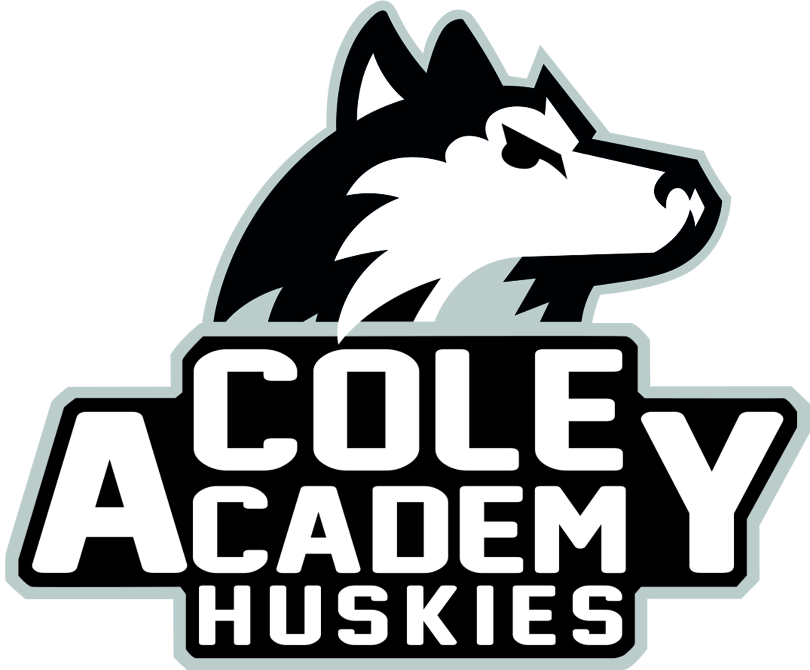
Cole Academy Cole Academy East
1915 W. Mount Hope 2921 E. Coleman Road
Lansing, Michigan 48910 East Lansing, Michigan 48823
517.372.0038 517.580.3470
Fax 517.372.1446 Fax 517.372.1446
District Annual Education Report (AER) Cover Letter

January 30, 2024

Dear Parents and Community Members:

We are pleased to present you with the Annual Education Report (AER) which
provides key information on the 2023-24 educational progress for Cole Academy
and our schools. The AER addresses the complex reporting information required by
federal and some requirements of state laws. Our staff is available to help you
understand this information. Please contact Mr. Rob Ellis for help if you
need assistance.

The DISTRICT AER is available for you to review electronically by visiting the
following website https://bit.ly/3AB0u6C, or you may review a copy in the main
office at your child’s school. Each school will also be communicating their own AER
to parents directly.

These reports contain the following information:

Student Assessment Data
· Includes the following three assessments: M-STEP (Michigan Student Test of
Educational Progress), MI-Access (Alternate Assessment), and College Board SAT
· Presents assessment information for English language arts and mathematics for
grades 3 to 8 and 11, and MI-Access science for grades 4, 7, and 11, compared to
state averages for all students as well as subgroups of students.

Educator Qualification Data
· Identifies the number and percentage of inexperienced teachers, principals,
and other school leaders
· Reports teachers who are teaching with emergency or provisional credentials
· Includes teachers who are not teaching in the subject or field for which they
are certified

NAEP Data (National Assessment of Educational Progress)
· Provides state results of the national assessment in mathematics and
reading every other year in grades 4 and 8

Civil Rights Data
· Provides information on school quality, climate, and safety
Review the table below listing our schools. For the 2023-24 school year, schools
were identified based on previous years’ performance using definitions and labels as
required in the Every Student Succeeds Act (ESSA). A Targeted Support and
Improvement (TSI) school is one that had at least one underperforming student
subgroup in 2018-19. An Additional Targeted Support (ATS) school is one that had a student subgroup performing at the same level as the lowest 5% of all schools in
the state in 2017-18. A Comprehensive Support and Improvement (CSI) school is
one whose performance was in the lowest 5% of all schools in the state or had a
graduation rate at or below 67% in 2016-17. Some schools are not identified with
any of these labels. In these cases, no status label is given.

School Name | Status Label | Key Initiative to Accelerate Achievement
Cole Academy, Lansing | No Label | Multi-Tiered Systems of Support
Cole Academy, East | No Label | Multi-Tiered Systems of Support

We are proud of our students and staff for their exemplary academic
achievement especially coming out of a global pandemic and their progress into the year following. Thank you to our community and families for their continued support of our staff and students!
Sincerely and gratefully,

Mr. Ellis

Superintendent

